# Worksheet 1B Processor components

1. A computer is designed to be programmed using simplified assembly language. The instruction in memory location 03 is ADD 06and is used to add the value stored in memory location 06 to the value stored in the Accumulator.  
     
   Numerical values are being used and are labelled with a # mark. The value currently in the accumulator is #40. There is a value of #15 in memory location 06.  
     
   Complete the diagrams of the states of the processor components at various stages in the Fetch-Execute cycles showing how the result of this instruction is determined and stored in the accumulator.   
     
   Also add to the diagram a description of what is happening at each part of the three main stages, (the first has been completed as an example): **Fetch – Stage 1**

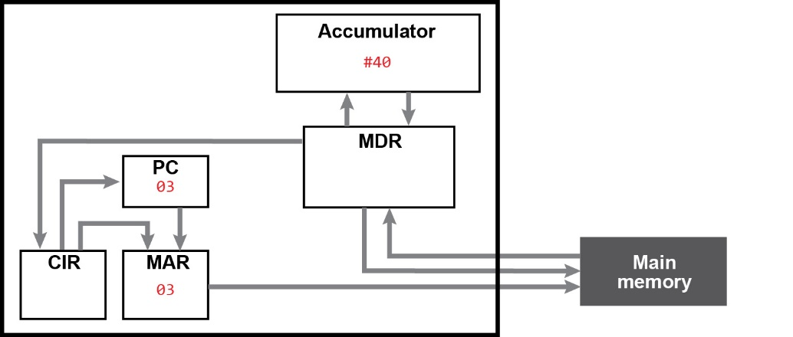

**Description of diagram:**

*The Program Counter contains the memory address of the next instruction to be processed, (03). This is copied into the Memory Address Register so that the instruction can be read. The memory location is requested to be read by the process.*

**Fetch – Stage 2**

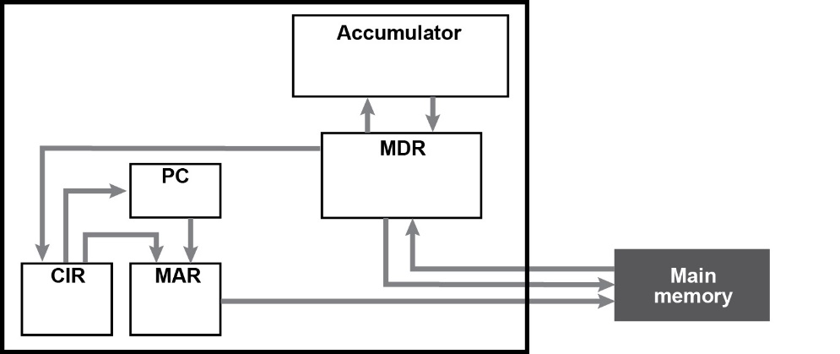

**Description of diagram:**

*Data in address of MAR value is retrieved from main memory and copied into MDR which the address is 03, so the MDR will retrieve “ADD 06” and program counter is incremented to 04.*

**Fetch – Stage 3**



**Description of diagram:**

**The instruction in MDR is then copied into CIR**

**Decode – Stage 4**



**Description of diagram:**

**“ADD 06” is decoded by being split into opcode and operand. The opcode is to perform an addition on accumulator, and operand holds memory address of the data to be added on, which is 06. 06 is copied into MAR, using the address, the data is retrieved from main memory which is #15 which is copied into MDR.**

**Execute – Stage 5**



**Description of diagram:**

*The data #15 has the instruction performed which is add #15 to accumulator. So accumulator becomes #55.*

1. The next instruction at address 04 is STA 07where the result of the previous instruction is written to memory. Describe broadly the process the Fetch-Execute cycle will follow to achieve this.

*04 is copied into MAR, program counter is incremented to 05, Instruction in memory location 04 is fetched from main memory, copied into MDR, which is then copied into CIR. Decoded, and operand copied into MAR while program counter increments to 06 and instruction fetched from memory. Repeat until program counter is 07 and then store the final value in accumulator is written to memory.*